A Project Report
on
Dungeon Explorer
Submitted in partial fulfillment of the requirement of
Project – VI [BIT356CO]
Bachelor in Information Technology

Submitted to

Purbanchal University
Biratnagar, Nepal

Submitted by
Alisha Shahi 360801]
Bhavishek Lama [360805]
Riya Phuyal [360828]

KANTIPUR CITY COLLEGE
Putalisadak, Kathmandu
May,2026
A Project Report
on
Dungeon Explorer
Submitted in partial fulfillment of the requirement of
Project – VI [BIT356CO]
Bachelor in Information Technology

Submitted to
Purbanchal University
Biratnagar, Nepal

Submitted by
Alisha Shahi [360801]
Bhavishek Lama [360805]
Riya Phuyal [360828]

Project Supervisor
Santosh Prakash Sah
Maryada Karki

KANTIPUR CITY COLLEGE
Putalisadak, Kathmandu
May,2026

Abstract
Dungeon Quest is a 2D tile-based action-adventure game developed using Python, designed to provide an engaging and dynamic gaming experience through AI-based procedural map generation. Players control a character who explores a procedurally generated cave-like dungeon composed of tiles such as ground, walls, obstacles, and other environmental elements. Unlike a fixed dungeon, the map is dynamically generated each time the player enters the same level, providing a different layout and exploration experience during each gameplay session.
The game applies artificial intelligence and data mining techniques to generate, validate, and optimize the dungeon environment. Cellular Automata is used to create natural cave-like structures, while Breadth-First Search (BFS) checks the connectivity and accessibility of generated areas. The A* algorithm is used for efficient pathfinding and to connect inaccessible regions when required. A Genetic Algorithm is applied to optimize the generated map based on factors such as connectivity, exploration space, and difficulty. Decision Tree techniques can be used for intelligent placement of enemies, resources, and other game elements, while data mining techniques analyze player behavior to improve future map generation.
The game follows object-oriented programming principles and a modular architecture, allowing different map-generation and AI components to be developed and maintained independently. The game continuously generates new dungeon layouts using random seeds, ensuring that the same level can provide a different environment each time it is played. This combination of procedural generation, artificial intelligence, and data mining make the game more dynamic and replayable while demonstrating the practical application of AI algorithms in 2D game development.

Acknowledgement
We would like to express our heartfelt gratitude to everyone who has supported and encouraged us throughout the completion of this project.
First and foremost, our sincere thanks go to Purbanchal University for introducing such a practical and insightful course, which has provided us the platform to explore and enhance our technical and academic capabilities.
We are deeply grateful to the entire team of Kantipur City College (KCC) for providing us with this valuable opportunity. We would especially like to extend our appreciation to the Principal of KCC, whose support and leadership have been instrumental in fostering an environment of learning and growth.
A special note of thanks goes to our respected supervisor, Santosh Prakash Sah and Maryada Karki whose consistent encouragement, guidance, and rich knowledge helped us throughout the course of this project. Their mentorship has truly been invaluable, and we could not have asked for better mentor.
We also acknowledge the contributions of each team member and our classmates, who shared suggestions, advice, and experiences that greatly enriched the project.
Finally, we extend our warmest thanks to our friends who supported us both directly and indirectly. Your encouragement and help made this journey smoother and more meaningful.

Alisha Shahi [360801]
Bhavishek Lama [360805]
Riya Phuyal [360828]

Declaration
We declare that this project report titled “Dungeon Explorer” submitted in partial fulfillment of the Bachelor of Information Technology is a record of original work carried out by us under the supervision of Santosh Prakash Sah and Maryada Karki and has not formed the basis for the award of any other degree or Diploma, in this or any other institution or University. In keeping with the ethical practice of reporting scientific information, due acknowledgments have been made wherever the findings of others have been cited.

Alisha Shahi [360801]
Bhavishek Lama [360805]
Riya Phuyal [360828]

Supervisor’s Approval
This is to certify that the project entitled “Dungeon Explorer” undertaken and demonstrated by Alisha Shahi, Bhavishek Lama and Riya Phuyal has been successfully completed under our supervision as a partial fulfillment of the requirements of the degree of BIT VI semester under Purbanchal University. We, henceforth, approve this project to be awarded the certificate by the concerned authority. During supervision, we found students hardworking, skilled and ready to undertake any professional work related to this field in future.

_____________
Santosh Prakash Sah
Project Supervisor
Department of IT

_____________
Maryada Karki
Project Supervisor
Department of IT

Certificate from Department
Following the Supervisor's Approval and Examiners' Acceptance, the project entitled “Dungeon Explorer” submitted by Alisha Shahi, Bhavishek Lama and Riya Phuyal as a partial fulfillment of the requirements for the degree of BIT 6th under Purbanchal University, has been officially awarded by this certificate. I wish the students all the best for their future endeavors.

______________
Saroj Pandey
HoD
Department of IT
Kantipur City College

______________
Rubim Shrestha
Project Coordinator
Department of IT
Kantipur City College

Table of Contents
Abstract i
Acknowledgement ii
Declaration iii
Supervisor’s Approval iv
Certificate from Department v
List of Figure viii
List of Table ix
List of Abbreviations x
1. Introduction 1
1.1 Overview 1
1.2 Problem Statement 1
1.3 Objectives 2
1.4 Features 2
1.5 Significance 3
1.6 Scope and Limitations 3
1.7 Documentation Organization 4
2. Literature Review 5
2.1 Planning Pod 5
2.1.1 Pros: 5
2.1.2 Cons: 5
2.2 Coursedog 5
2.2.1 Pros: 5
2.2.2 Cons: 5
2.3 Accelevents 6
2.3.1 Pros: 6
2.3.2 Cons: 6
2.4 Eventbrite 6
2.4.1 Pros: 6
2.4.2 Cons: 6
2.2 Summary of Literature Review 6
3. Methodology 8
3.1: Software Development Life Cycle 8
3.1.1: Selected Model 8
3.2 Technologies and Tools used 9
3.2.1 Programming Language (PHP) 9
3.2.2 Database (MYSQL) 9
3.2.3 Software Used 9
3.2.4 Integrated Development Environment (IDE) 9
3.3 Roles and Responsibilities 10
4. System Analysis 11
4.1 Requirement Analysis 11
4.1.1 Requirement Gathering 11
4.1.2 Functional Requirement 12
4.2 Feasibility Study 12
4.2.1 Technical Feasibility 12
4.2.2 Economics Feasibility 13
4.2.3 Schedule Feasibility 13
5. System Design and Implementation 15
5.1 System Architecture 15
5.1.1 Presentation Layer (Frontend) 15
5.1.2 Business Logic Layer (Backend) 15
5.1.3 Data Layer (Database) 15
5.2 Diagrams 16
5.2.1 DFD Level 0 16
5.2.2 DFD Level 1 17
5.2.3 Use case Diagram 18
5.2.4 ER-Diagram 19
6. Testing and Debugging 20
6.1 Tools used in Testing 20
6.2 Test case 20
7. System Development and Implementation 24
7.1 Programming Platform 24
7.2 Operating Environment 24
8. Conclusion 25
References 26

List of Figure
Figure 3.1: Waterfall model 8
Figure 4.1: Gantt chart 14
Figure 5.1: DFD level 0 16
Figure 5.2: DFD level 1 17
Figure 5.3: Use Case Diagram 18
Figure 5.4: ER-Diagram 19

List of Table
Table 3.1: Roles and responsibility 10
Table 4.1: Requirement Gathering 11
Table 4.2: Functional Requirement 12
Table 6.1: Tools used in Testing 20
Table 6.2: Test Case 20

List of Abbreviations
Data Flow Diagram
Entity Relationship
Graphical User Interface
JavaScript Object Notation
Kantipur City College
My Structured Query Language
Visual Studio Code
Cross-Platform, Apache, MariaDB, PHP And Perl
DFD
ER
GUI
JSON
KCC
MYSQL
VS Code
XAMPP

Introduction
Dungeon Explorer is a single-player, 2D tile-based dungeon action game written in Python using the Pygame library, which involves exploring dungeons. The goal of the project is to create a distinct type of cave-like dungeon map each time the player enters the same level. To produce map, it makes use of Cellular Automata coupled with AI and data mining technologies such as BFS, A*, Genetic algorithm and Decision Tree to enhance map connection, optimization and gameplay.

Overview
The player can launch the game and access the dungeon from the menu at the start of the game. The same level has different layout each time since a new cave-like map is dynamically created at the beginning of each level. The player controls a character using keyboard and mouse control and explores the produced dungeon while avoiding traps and monsters while using game items.
The dungeon map is created by the game using Cellular Automata, A* facilitates pathfinding, and BFS verifies connection. Decision Tree can be utilized for resource and enemy placement while Genetic Algorithm aids in optimizing the created map. To enhance the creation of maps in the future, player gameplay data is gathered and examined utilizing data mining techniques.

Problem Statement
- Repetitive gameplay: Once a player has memorised a fixed level, replaying it adds nothing. Large hand-authored worlds are also extremely expensive to produce, so most games of this scale reuse a small number of levels.
- Poor replay value from randomness alone: Simply filling a grid with random tiles does not produce a good level. The result is usually full of unreachable regions, single-tile artefacts and awkward bottlenecks that make the level frustrating rather than interesting.
- No guarantee of playability: Because connectivity is never verified, a generated map can be impossible to finish. There is no automated check that the exit door can actually be reached from the player’s spawn point.
- Difficulty does not adapt: Fixed maps offer the same challenge to every player, whether they are playing for the first time or have completed the level fifty times.

1.3 Objectives
The objective of the project is:
- To develop a 2D tile-based dungeon exploration game using Python.
- To generate a different cave-like dungeon map each time the player enters the same level.
- To use AI algorithms such as Cellular Automata, BFS, A*, and Genetic Algorithm for map generation, connectivity, and optimization.
- To use data mining techniques to analyze player behavior and improve future gameplay.

1.4 Features
Some of the features of the following project are:
- Role-Based Access: The system differentiates between Admin and Student roles, providing appropriate menus, permissions, and functionalities.
- Admin Functions: Admin can create, organize, update, and manage events as well as student details, send notices and oversee lost-and-found reports.
- Student Functions: Students can browse available events, register for events, request event and participate easily through the system.
- Lost and Found Management: Users can report lost items, post found items while admin updates item status efficiently.
- Event Registration Control: Admin can monitor and manage participant registrations, ensuring organized event planning and execution.

1.5 Significance
The Dungeon Explorer System plays a crucial role in modernizing event management and student service coordination by automating event planning, registration, notifications, and lost-and-found processes. By reducing manual paperwork and traditional communication barriers, the system ensures faster, more accurate, and organized management of events and student-related services. It provides timely access to event information, registration updates, and lost-and-found tracking for students and administrators, improving communication, transparency, and operational efficiency. This project highlights the importance of web-based applications in educational and organizational management by offering a cost-effective, scalable, and reliable solution for efficiently handling events, enhancing student participation, and improving support services.

1.6 Scope and Limitations
The scope of the Dungeon Explorer System is to design and implement a web-based solution for efficient management of events, student registrations, and lost-and-found services. Using PHP, HTML5, CSS3, and MySQL, the system allows administrators and students to securely access and manage event-related activities and item tracking through a centralized web application. Users can perform tasks such as creating and managing events, registering for events, reporting lost or found items, and tracking their status through a unified dashboard. The system aims to reduce manual workload, minimize communication gaps, improve transparency, and provide real-time access to event information and lost-and-found records from any location.
While developing the project, some advanced features were considered but could not be implemented due to time and resource constraints. These include:
- The system does not include a mobile application version, as it is currently designed only as a web-based platform.
- Advanced analytics or reporting features for event participation trends and lost-and-found statistics are not implemented.

1.7 Documentation Organization
This documentation provides a complete overview of the Dungeon Explorer System. Introduction provides the background, objectives, features, scope, and overall significance of the project. Further topic describes the system design, detailed operation of event management and student registration, as well as the functionality of the lost-and-found module. It also includes the database structure, system workflow, and implementation details using PHP, HTML5, CSS3, and MySQL. The report highlights how the system improves upon traditional event handling methods and explains the centralized database approach and web-based communication process between users and the system.

Literature Review

2.1 F.E.A.R. (2005)
F.E.A.R. is considered one of the earliest commercial games with highly intelligent enemy AI. The enemies combine a Finite State Machine with GOAP to make tactical decisions in real time. The FSM controls states such as patrol, search, attack, and retreat, while A* computes efficient paths through the environment. Instead of following fixed scripts, enemies dynamically choose actions such as taking cover, flanking the player, or retreating based on the combat situation, resulting in more realistic and adaptive gameplay.
- AI Algorithms Used:
- Finite State Machine (FSM)
- A* Pathfinding
- Goal-Oriented Action Planning (GOAP)

2.2Pac-Man (1980)
Pac-Man is one of the earliest examples of AI in video games. Each ghost operates using predefined behavioral states such as Chase, Scatter, and Frightened. These states are controlled by a Finite State Machine, while simple pathfinding and targeting rules determine movement toward Pac-Man. Each ghost follows a different targeting strategy, making gameplay challenging despite relatively simple algorithms.
- AI Algorithms Used:
- Finite State Machine
- Rule-Based Decision Making
- Pathfinding

2.3 Left 4 Dead
Left 4 Dead introduced the AI Director, which continuously monitors player health, movement, stress level, and progress through the map. Using this information, the game dynamically changes enemy spawning, attack frequency, and item placement to maintain an engaging level of challenge. Individual infected enemies also use FSMs for behavior and A* navigation for movement. While the AI Director is not specifically based on K-Means or Markov Chains, it adapts the game according to player behavior.
- AI Algorithms Used:
- FSM
- A* Navigation
- AI Director (player behavior analysis)

2.4 Terraria
Overview
- 2D sandbox adventure game developed by Re-Logic.
- Released in 2011.
- Uses procedural world generation to create a unique world for every new game.
- Each world contains randomly generated terrain, caves, biomes, dungeons, floating islands, and resources.
- Once a world is created, it is saved and remains unchanged unless a new world is generated.
Algorithms/Techniques Used
1. Random Seed
- Generates a unique world based on a seed value.
- Using the same seed recreates the same world.
- Different seeds generate different maps.
2. Noise-Based Terrain Generation (Confirmed)
- Generates hills, mountains, valleys, and terrain height.
- Creates smooth natural landscapes.
3. Cellular Automata (Commonly Reported for Cave Formation)
- Produces natural-looking underground caves.
- Smooths randomly generated cave structures.
- Eliminates unnatural isolated walls.
4. Rule-Based Generation
- Places dungeons, pyramids, floating islands, jungle, corruption/crimson, and snow biomes.
- Ensures structures appear in logical locations.
5. Flood Fill / Connectivity Checking (Likely)
- Ensures cave regions remain connected.
- Prevents inaccessible underground areas.

2.5 Core keeper
Overview
- 2D underground sandbox survival game.
- Released in 2022.
- Focuses on procedurally generated cave exploration.
- Every new game creates a unique underground world.
- Includes caves, tunnels, resources, enemies, and bosses.
Algorithms/Techniques Used
1. Random Seed
- Creates a different underground world for each new game.
- Allows unlimited replay ability.
2. Cellular Automata (Likely)
- Generates realistic cave layouts.
- Produces connected underground environments.
3. Graph-Based Region Generation (Likely)
- Connects different cave regions and biomes.
- Maintains exploration flow.
4. Rule-Based Placement
- Places resources, enemies, bosses, and structures.
- Controls game progression.
5. Pathfinding Algorithms (A for NPCs)*
- Used by enemies to navigate the generated world.
- Enables intelligent movement around obstacles.

2.6 Minecraft
Overview
- 3D sandbox game developed by Mojang Studios.
- Released in 2011.
- Generates a unique world for every new game.
- World includes terrain, caves, rivers, villages, and biomes.
- Generated world is saved permanently after creation.
Algorithms/Techniques Used
1. Random Seed
- Generates a unique world.
- Same seed always recreates the same map.
2. Perlin Noise / Noise Functions (Confirmed)
- Generates terrain elevation.
- Creates mountains, oceans, valleys, and landscapes.
3. Cave Generation Algorithms (Multiple Techniques)
- Creates branching underground cave systems.
- Produces natural cave networks.
4. Rule-Based Structure Placement
- Generates villages, temples, strongholds, and mineshafts.
- Ensures structures appear in appropriate biomes.
5. A Pathfinding (Confirmed for AI)*
- Used by mobs and villagers.
- Allows intelligent navigation around obstacles.

Methodology

3.1: Software Development Life Cycle
By following an SDLC model, the development process can be broken down into manageable phases, allowing for better planning, tracking progress, and ensuring quality control. It also helps in identifying potential risks and errors at an early stage and addressing them effectively, which is essential when dealing with sensitive data such as user information and event data.
Additionally, using an SDLC model ensures that the final product meets the needs and expectations of all parties involved. Overall, incorporating an SDLC model in the development of Dungeon Explorer helps streamline the process, minimize errors, and deliver a reliable and efficient software solution.

3.1.1: Selected Model
For this project, SDLC model was selected. This model combines the structured nature of traditional SDLC with the flexibility of iterative development. It is particularly suitable for small-scale, personal projects with limited timelines and evolving requirements.
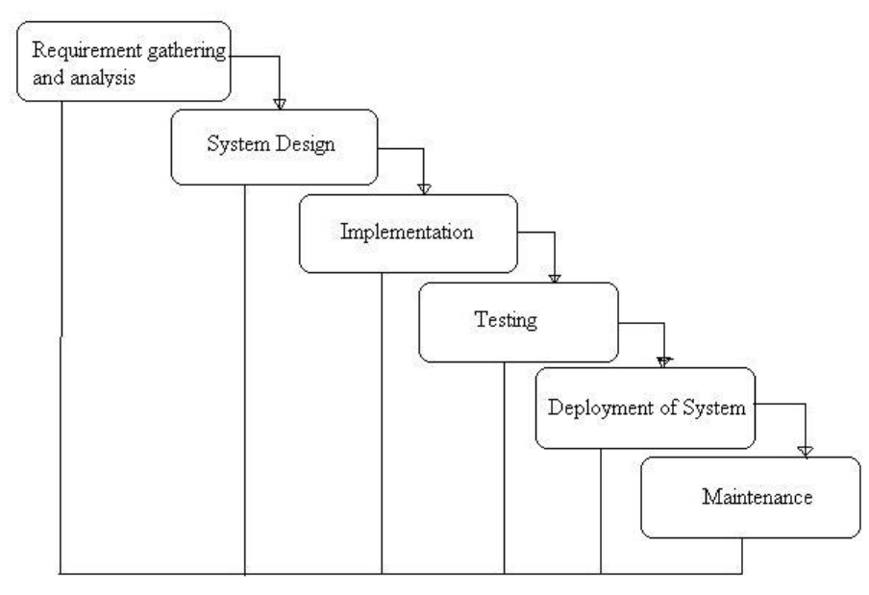
Figure 3.1: Waterfall model
The iterative model allows the system to be developed in small increments, where each iteration includes requirement analysis, design, implementation, and testing. Feedback from each iteration is used to improve the system in subsequent cycles.
Justification for Model Selection
- The project has a short development duration of few months.
- Requirements may evolve during development.
- Early delivery of a working prototype is beneficial.
- The model supports continuous testing and refinement.
- It reduces the risk of major failures at later stages.

3.2 Technologies and Tools used

3.2.1 Programming Language (PHP)
PHP is used as the primary server-side programming language for developing the backend of the system. It handles client requests, processes business logic, manages sessions, and interacts with the database. PHP is widely used for web development due to its simplicity, flexibility, and strong support for database integration, making it suitable for dynamic web applications like this project.

3.2.2 Database (MYSQL)
MySQL is used as the relational database management system for storing all system data, including user information, event details, registration records, notifications, and lost-and-found data. It provides efficient data storage, fast query processing, and supports structured relationships between tables. The database ensures data consistency, integrity, and secure access throughout the application.

3.2.3 Software Used
Apache is used as the web server to run the PHP-based application locally or on a hosting environment. HTML5 and CSS3 are used to design and structure the frontend of the system, providing a clean, responsive, and user-friendly interface for both administrators and students.

3.2.4 Integrated Development Environment (IDE)
Visual Studio Code (VS Code) is used as the main Integrated Development Environment for developing the Dungeon Explorer System. It provides features such as syntax highlighting, code auto-completion, debugging support, extensions for PHP development, and easy project management, which improves development efficiency and reduces coding errors.

3.3 Roles and Responsibilities
Table 3.1: Roles and responsibility
Team Member | Task Performed
Alisha Shahi | - Coding  - Write PHP logic  - Database creation and connection  - Testing and Debugging  - Unit testing of each backend  - Check the connection of frontend with php  - Documentation
Bhavishek Lama | - Coding  - Write JavaScript logics  - Handle verifications and fetching data from backend for frontend  - Testing and Debugging  - Checking response and payload during operations  - Validation and other functions  - Documentation
Riya Phuyal | - Coding  - Create all HTML pages/forms  - Design the website using CSS  - Make pages responsive  - Testing and Debugging  - Test responsiveness of the page  - Testing the position of elements  - Documentation

System Analysis

4.1 Requirement Analysis
Requirement’s analysis is the process of identifying and documenting the functional and non-functional needs of a system. It helps in understanding what the system should do and how it should perform.
In this project, requirements analysis is carried out to identify the needs of the Dungeon Explorer System developed using PHP with HTML5, CSS3, and MySQL. The analysis focuses on defining secure login mechanisms, role-based access for Admin and Student, efficient event creation and management, student registration for events, notification handling, and a lost-and-found reporting and tracking system.

4.1.1 Requirement Gathering
Requirement gathering is the process of collecting information about user needs and system expectations. In this project, requirements were gathered through discussions with other project members, supervisor and classmates as well as by observing the existing games.
Table 4.1: Requirement Gathering
Requirement ID | Description
R1
  The system shall provide secure login and role-based access control for Admin and Student users.
R2 | The system shall allow the admin to create, manage, and organize events and control student registrations.
R3 | The system shall allow students to browse events, pre-register for events, and receive notifications.
R4 | The system shall allow users to report lost items, post found items, and search for matching records.
R5 | The system shall store and manage all event, registration, and lost-and-found data in a centralized MySQL database with a user-friendly web interface.

4.1.2 Functional Requirement
Table 4.2: Functional Requirement
Function ID | Description | Cross Reference with Requirement
F1 | User authentication and role-based access control for Admin and Student. | R1
F2 | Admin management of event creation, updates, deletion, and control of student registrations. | R2
F3 | Student browsing of events, pre-registration, and receiving notifications about events. | R3
F4 | Student reporting of lost items, posting found items, and searching for matching records in the system | R4
F5 | Centralized storage and retrieval of event, registration, and lost-and-found data through a web interface. | R5

4.2 Feasibility Study
Feasibility study is conducted to determine whether the proposed system is practical, cost-effective, and can be completed within the given time frame

4.2.1 Technical Feasibility
Technical feasibility assesses whether the technology, tools, and skills required to develop the system are available and suitable. For this project:
- PHP is used as the main backend programming language, which is widely supported for web development.
- HTML5 and CSS3 are used for creating a responsive and user-friendly web interface.
- MySQL provides centralized and efficient data storage for events and lost-and-found records.
- The development team has the necessary skills in web development, database management, and system design.

4.2.2 Economics Feasibility
Economic feasibility evaluates whether the cost of developing the system is justified by the benefits it will provide. For this project:
- Uses open-source technologies such as PHP, MySQL, HTML5, and CSS3, resulting in no licensing cost.
- Requires only basic hardware (computer system and local server setup like XAMPP).

4.2.3 Schedule Feasibility
Schedule feasibility examines whether the system can be completed within the allocated time frame. For this project:
- The project duration is approximately 5 months.
- Major phases include requirement analysis, system design, implementation, testing, and documentation.
- The small development team can efficiently manage tasks within the given schedule.

Activities | Feb 2026 |  |  |  | March 2026 |  |  |  | April 2026 |  |  |  | May 2026
Week | 1 | 2 | 3 | 4 | 1 | 2 | 3 | 4 | 1 | 2 | 3 | 4 | 1 | 2 | 3 | 4
Project Start (Discussion)
Requirement Analysis
System Design
Frontend Development
Backend Development
Testing
Fixing Bugs
Documentation

Figure 4.1: Gantt chart

System Design and Implementation

5.1 System Architecture
The Dungeon Explorer is designed using a PHP-based backend with HTML5 and CSS3 for the frontend interface. The system follows a “three-tier architecture”, consisting of the Presentation Layer, Business Logic Layer, and Data Layer, ensuring modularity, scalability, and easy maintenance.

5.1.1 Presentation Layer (Frontend)
- Built using HTML5 and CSS3, this layer provides a user-friendly interface for all system roles: Admin and Student.
- It handles user input, displays web pages such as login forms, event listings, registration forms, and lost-and-found reporting pages.
- Ensures responsive and simple design for smooth user experience.

5.1.2 Business Logic Layer (Backend)
- Developed using PHP, this layer implements the core functionality of the system.
- It manages user authentication, role-based access control, event management, student registration processing, and lost-and-found operations.
- It acts as a bridge between the frontend and the database, processing all user requests.

5.1.3 Data Layer (Database)
- A centralized MySQL database is used to store all system data, including user information, event details, registration records, notifications, and lost-and-found data.
- It ensures data integrity, security, and efficient data retrieval for the application.

5.2 Diagrams

5.2.1 DFD Level 0
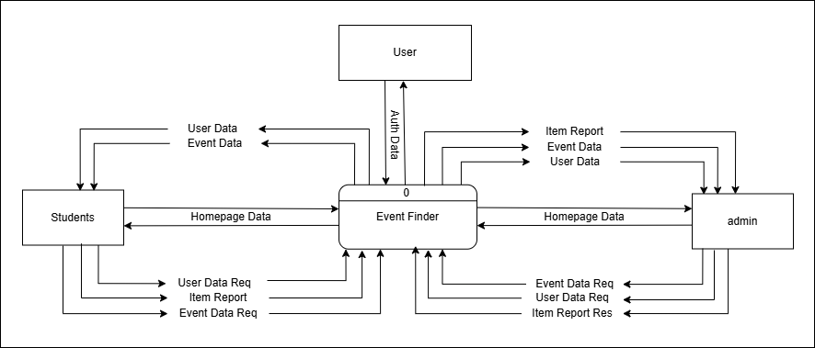
Figure 5.1: DFD level 0

5.2.2 DFD Level 1
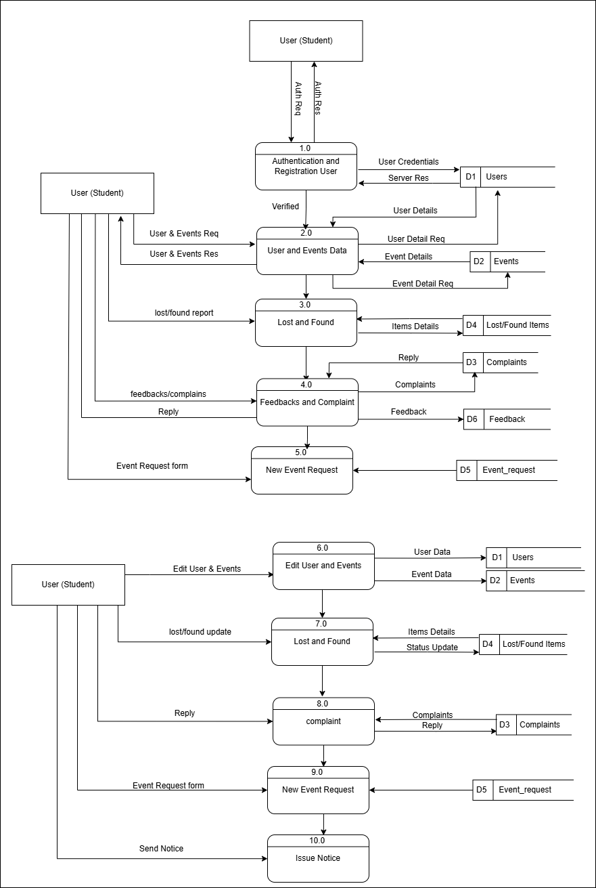
Figure 5.2: DFD level 1

5.2.3 Use case Diagram
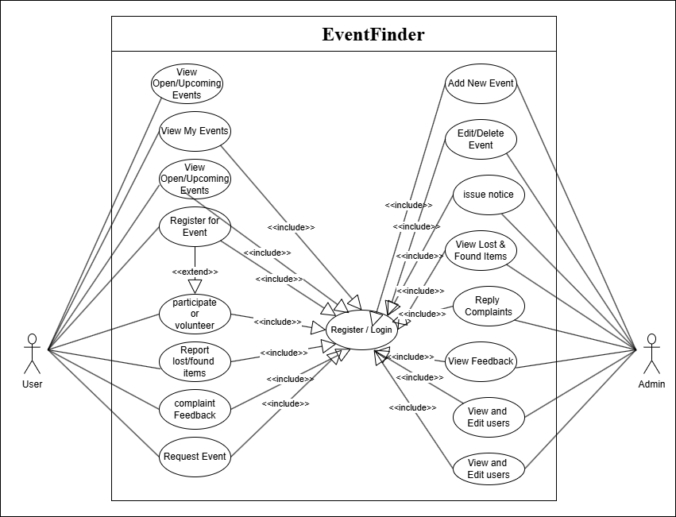
Figure 5.3: Use Case Diagram

5.2.4 ER-Diagram
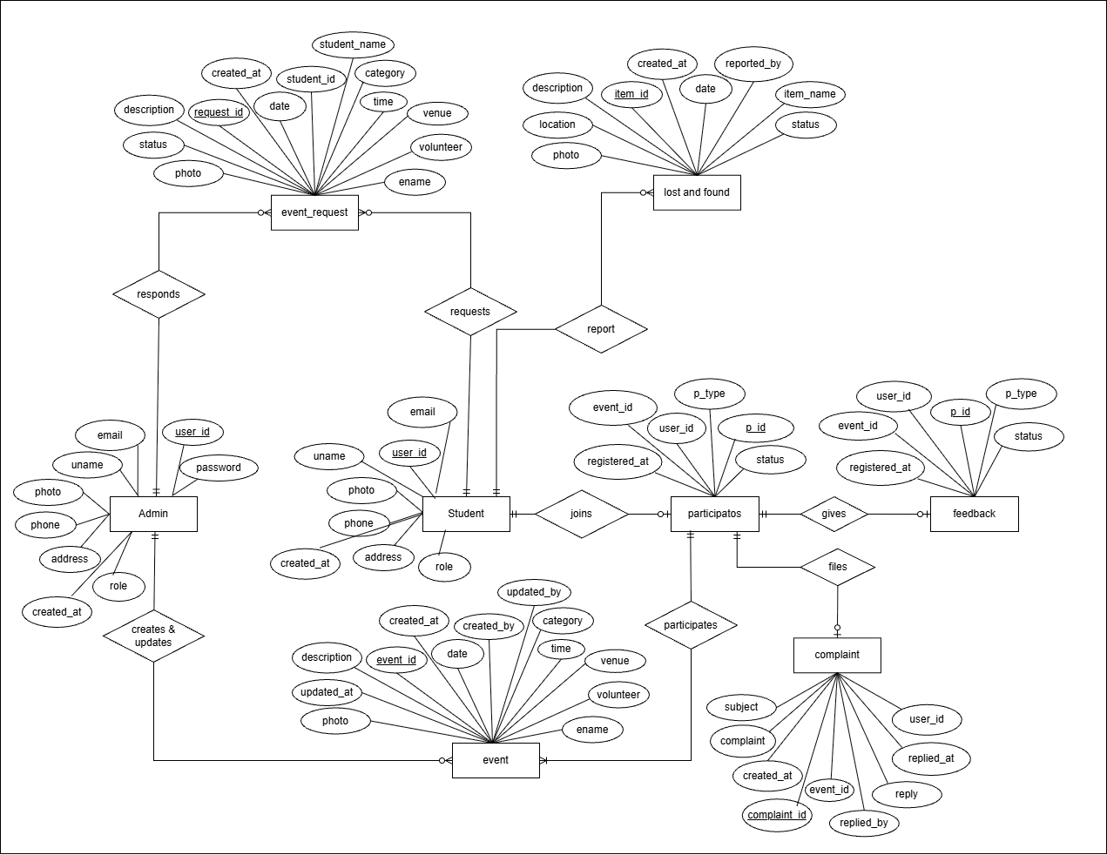
Figure 5.4: ER-Diagram

Testing and Debugging
The system was tested to ensure all modules function correctly, including login, event management, student registration, and lost-and-found features. Testing was performed to identify and fix errors in code, database connectivity, and user interface issues. This ensures that the system works efficiently and meets user requirements.

6.1 Tools used in Testing
Table 6.1: Tools used in Testing
S.N. | Tools | Specification
1 | Hardware (Laptop) | Acer nitro V 16 AMD Ryzen 7 8845HS  Dell Inspiron Intel Core i5-1135G7  Lenovo IdeaPad Intel Core i5-8548U
2 | Testing software | Visual studio code  XAMPP control panel

6.2 Test case
Table 6.2: Test Case
SN | Test objective | Expected Output | Result | Remarks
1 | Signup with digit in name | Button disable with feedback | Button disable | pass
2 | Signup with regular email | Button disable with feedback | Button disable | pass
3 | Signup with college email | Button enable with no feedback | Button enables | pass
4 | Signup with 11 digits in phone | Button disable with feedback | Button disable | pass
5 | Signup with 9 digits in phone | Button disable with feedback | Button enables | Fail  (no digit’s limit for 10 98)
6 | Signup with 9 digits in phone | Button disable with feedback | Button disable | pass
7 | Signup with 98/97 digit in phone | button enables and no feedback | Button enables | pass
8 | Signup with password without uppercase letter | Button disable with feedback | Button disable | pass
9 | Signup with password without symbol | Button disable with feedback | Button disable | pass
10 | Signup with password without digits | Button disable with feedback | Button disable | pass
11 | Signup with password without uppercase letter | Button disable with feedback | Button disable | pass
12 | Signup with password with only 7 letters | Button disable with feedback | Button disable | pass
13 | Signup with correct format password | Button enable with no feedback | Button enables | pass
14 | Signup with different confirm password | Button disable with feedback | Button disable | pass
15 | Signup with no photo | Button enable with no feedback | Button enables | pass
16 | Signup with photo | Button enable with no feedback | Button enables | pass
17 | login with wrong credentials | Feedback and clears input fields | Shows feedback and back to page | pass
18 | login with student credentials | Opens student homepage | Nothing happens | Fail, no database
19 | login with student credentials | Opens student homepage | Opens homepage | pass
20 | login with admin credentials | Opens admin homepage | Opens homepage | pass
21 | Homepage shows upcoming and recent events | Displays events in grid | Displays events | Pass  but can’t see event detail
22 | Show detail | Displays event detail | nothing only buttons | Fail, event id not sent
23 | Show detail by sending event id in URL (using GET) | Displays event detail | Displays event detail and buttons | pass
24 | User profile | Shows users photo and details | Shows default photo | fail
25 | User profile by fetching user data | Shows users photo and details | Shows users photo and details | pass
26 | Lists all the events participated by user | Shows event names and button | Shows list | pass
27 | List registered events by user | Shows event names and button | Shows list | pass
28 | Edit user | Displays user detail and input fields | Opens form with details | pass
29 | Edit user | Updates user data | Updates data in database | pass
30 | history | Lists user feedback, complaint and event request | Failed to display history | fail
31 | History after adding complaint, feedback and event requests | Lists user feedback, complaint and event request | Lists user history | pass
32 | Feedback and complaint | Displays event details with input field | Opens modal | pass
33 | Lost and found | Opens a reporting modal | Opens modal | Fail, data not sent to database
34 | Lost and found after fetching event id | Sends data to the database | Sends data | pass
35 | Cerate events | Opens event creation modal | Opens modal | pass
36 | Issue notices | Opens notice modal | Opens modal and sends mail to all users | Fail, doesn’t send mail

System Development and Implementation

7.1 Programming Platform
- Main Language: PHP – used for backend functionality, processing logic, and handling server-side operations of the system.
- IDE / Software Used: Visual Studio Codes (VS Code) – for coding, debugging, and project management.
- Frontend Tools: HTML5 and CSS3 – for building a user-friendly and responsive and structured interface.
- Database Connectivity: MySQL – used to connect PHP with the MySQL database for data storage and retrieval.

7.2 Operating Environment
- Hardware: Intel Core i3+, 4 GB RAM, 500 MB storage
- Software: Any Modern Operating System (Windows/Linux/Mac), XAMPP/WAMP Server, MySQL, Chrome/Firefox browser
- Tested On: Windows 11 with XAMPP server, Visual Studio Code, MySQL database, and Google Chrome browser

Conclusion
The Dungeon Explorer System provides a simple and efficient platform for managing events, student registrations, and lost-and-found services. It helps reduce manual work, improves communication, and ensures centralized data management. The system successfully meets its objectives and can be further enhanced in the future with additional features like mobile support and advanced notifications.

References
Coursedog. Integrated Academic Operations Platform. Coursedog. https://www.coursedog.com/
Documentation. PHP. https://www.php.net/docs.php
Event management software. Accelevents Event Platform. https://www.accelevents.com/
Eventbrite. https://www.eventbrite.com/
MozDevNet. (1969, November 1). MDN. MDN Blog RSS. https://developer.mozilla.org/
MySQL documentation. MySQL. https://dev.mysql.com/doc/
Planning pod - venue management software venues actually run on. Planning Pod - Venue management software venues actually run on. https://planningpod.com/

